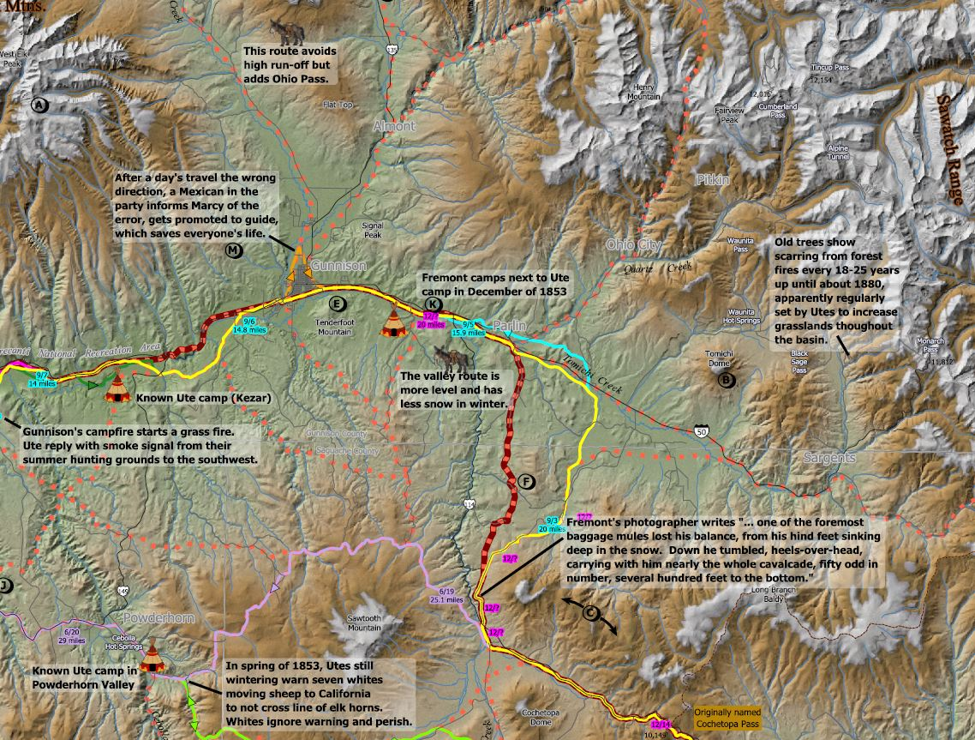

Hear Mike Pelletier and Dave Primus talk about mapping historical routes and sites in the Gunnison Country, and the stories they learned along the way"

Wednesday, January 27th, 7pm

@ the Gunnison Library

a presentation by

Mike Pelletier and Dave Primus

Mapping the History of the Gunnison Country

